**VIETNAM NATIONAL UNIVERSITY HO CHI MINH CITY**

**HO CHI MINH UNIVERSITY OF TECHNOLOGY**

**OFFICE FOR INTERNATIONAL STUDY PROGRAMS**

**FACULTY OF TRANSPORTATION ENGINEERING**

**🙝🙝🙝🙝🕮🙟🙟🙟🙟**

**Capstone Project**

**Modelling, simulation, and control of assisting motor and control rules of Electric Powered Steering (EPS) system.**

**Instructor: PhD. Ngô Đắc Việt**

**PhD. Trần Đăng Long**

**Student Name: Đặng Minh Duy**

**Student ID: 1910933**

**Class: CC19OTO1**

**🙝Semester 222🙝**

**🙝May 22nd 2023🙝**



**ACKNOWLEDGEMENT**

First of all, I would like to thank you, especially the teachers in the faculty for wholeheartedly guiding and imparting knowledge to me during the process of studying and training at Hồ Chí Minh University of Technology so that I can complete my graduation project in the best way.

I would like to express my sincere thanks to Ph.D Ngô Đắc Việt and Ph.D Trần Đăng Long, who has always followed closely and helped wholeheartedly, gave suggestions and pointed out the mistakes that he made, helping him correct errors during the process of implementing his graduation project.

I would also like to thank all my classmates who have studied and helped each other in the learning process as well as in the process of implementing this project.

And I would also like to thank the reviewer and the teachers in the department for imparting knowledge, giving me comments and suggestions so that I can complete my graduation project.

Finally, we would like to wish you good health and success to all of people in Hồ Chí Minh University of Technology.

**ABSTRACT**

It can be seen that the automobile industry is a measure of the country's economic development. If just a few years ago, this industry was considered a "luxury" in our country, now, along with the rapid development of the country, the automobile industry is booming strongly.

The use of cars as the main means of transportation is gradually becoming more popular, especially in big cities and densely populated areas. And in today's new cars, EPS electric steering is widely used in modern cars to minimize drag and enhance the driving experience. This is one of the systems that plays an important role and is likened to the standard system on modern cars. Therefore, now the automotive industry is increasing research and development of effective control methods for EPS electric steering systems. Therefore, I chose the graduation project topic: "Simulation and design of power motor control rules of EPS electric steering system on Matlab Simulink/Simscape." Simulation and design of control rules for power steering motors of EPS electric steering systems is an important topic in the field of automotive electronic engineering. Through the graduation project, I will apply the theoretical foundations of EPS electrical system including main components, kinematics, driving system dynamics to research the following contents:

+ Build a mathematical model of the power steering motor, use the specifications of the motor to determine the parameters of the model.

+ Building Simulink/Simscape models to simulate EPS electric steering system and power steering motor.

+ Design control rules for power steering motor based on mathematical model and Simulink / Simscape model.

+ Perform simulation and test the performance of the power assist motor control system on Simulink / Simscape model.

**LIST OF CONTENTS**

I. INTRODUCTION 9

1.1 Introduction to Electric Power Steering (EPS) System 9

1.1.1 Steering system 9

1.1.2 Electric power steering (EPS) system 10

1.2 Introduction to Simulink and Simscape 13

1.3 Project Objectives 17

1.4 Working conditions 17

1.5 Technical requirements 17

1.6 Limitation 17

II. THEORETICAL BASIS 18

2.1 Overall Structure and Working Principles of EPS System 18

2.1.1 Overall structure 18

2.1.2 Working principles 22

2.2 Dynamic Equilibrium Equations of EPS System 22

2.3 Overall Diagram and Control Rules of EPS System 27

2.4 PID Controller 28

III. SIMULATION PROCESS 31

3.1 Creating A Path for The Vehicle 31

3.2 Driver Block 38

3.3 Steering System 39

3.4 Vehicle Model 40

3.5 Electric Motor Model 42

IV. SIMULATION RESULTS AND EVALUATION 52

V. CONCLUSION 57

VI. FUTURE WORK AND ENHANCEMENTS 61

VII. REFERENCE 62

**LIST OF FIGURES**

Figure 1 Components of a steering system 9

Figure 2 Components of a steering system with Electric Power Steering 11

Figure 3 Sinulink user interface 14

Figure 4 Simscape user interface 15

Figure 5 EPS structure 18

Figure 6 Torque sensor of EPS 19

Figure 7 Steering angle sensor of EPS 19

Figure 8 Control module of EPS 20

Figure 9 Electric motor of EPS 21

Figure 10 Reduction gear of EPS 21

Figure 11 EPS structure 23

Figure 12 EPS structure (from steering wheel to torsion bar input) 24

Figure 13 EPS structure (Rotor shaft of the motor) 24

Figure 14 EPS structure (from the torsion bar output to the steering mechanism) 25

Figure 15 EPS block diagram 27

Figure 16 A PID controller structure 29

Figure 17 A driving scenario - lane changing 31

Figure 18 Heading angle of a vehicle 32

Figure 19 Position of the Set Path block in the model 32

Figure 20 Structure of Set Path block 33

Figure 21 Set path of vehicle at 10km/h 35

Figure 22 Set heading angle of vehicle at 10km/h 35

Figure 23 Set path of vehicle at 40km/h 36

Figure 24 Set heading angle of vehicle at 40 km/h 36

Figure 25 Set path of vehicle at 80 km/h 37

Figure 26 Set heading angle of vehicle at 80 km/h 37

Figure 27 Position of driver block in the model 38

Figure 28 Structure of Driver block 38

Figure 29 Position of Steering system block in the model 39

Figure 30 The complete 3D model of steering system 39

Figure 31 Inputs and outputs of steering system block 40

Figure 32 Position of Vehicle Body 3DOF block in the model 41

Figure 33 Vehicle Body 3DOF Single Track block 41

Figure 34 Vehicle Body 3DOF Dual Track block 42

Figure 35 Electric equivalent circuit of the armature and the free-body diagram of the rotor 43

Figure 36 DC motor model using dynamic equations 45

Figure 37 DC Machine block in MATLAB/Simulink 45

Figure 38 DC motor model using DC Machine block 46

Figure 39 Control diagram of electric motor 47

Figure 40 Control model of DC motor model using dynamic equations 47

Figure 41 Control model of DC motor model using DC Machine block 47

Figure 42 PID Tuner app user interface in MATLAB/Simulink 48

Figure 43 Output response of DC motor model using dynamic equations 49

Figure 44 Output response of DC motor model using DC Machine block 49

Figure 45 Output response of DC motor model using dynamic equations 50

Figure 46 Output response of DC motor model using DC Machine block 50

Figure 47 Overall structure of the model 52

Figure 48 Driver steering torque at set path 10km/h 53

Figure 49 Steering wheel angle at set path 10km/h 53

Figure 50 Driver steering torque at set path 40km/h 55

Figure 51 Steering wheel angle at set path 40km/h 56

Figure 52 Driver steering torque limits 57

Figure 53 Driver steering torque limits from the article - A New Control Strategy of an Electric-Power-Assisted Steering System 58

LIST OF TABLES

Table 1 Parameters of motor 44

# **I. INTRODUCTION**

## **1.1 Introduction to Electric Power Steering (EPS) System**

### **1.1.1 Steering system**

The steering system is one of the most important systems in any vehicle. It allows the driver to control the direction of movement and maneuver the vehicle as desired. A properly designed steering system provide drivers with precise control, feedback, and assistive power for safe and comfortable driving.

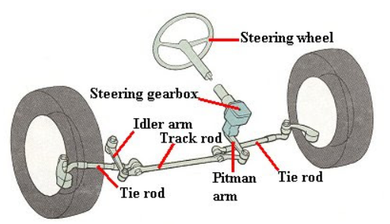

Figure 1 Components of a steering system

The basic components of a steering system are the steering wheel, steering column, steering gearbox, and linkages. The steering wheel allows the driver to input commands by turning left or right. The steering column transfers this rotational motion to the gearbox located under the vehicle. The steering gearbox then converts the rotation into linear motion that moves the steering linkages and turns the wheels. Various types of steering gearboxes are used, including rack and pinion, recirculating ball and worm and roller. The wheels are connected to the gearbox via tie rods, drag links and other linkages.

Early vehicles had direct mechanical steering with no power assistance. Drivers had to exert significant effort when turning the wheels at low speeds or parking. To reduce driver fatigue, power steering systems were introduced using hydraulic pressure or electric motors. Power steering valves control hydraulic pressure depending on how much the steering wheel is turned. Electric power steering systems use motors that sense steering torque and provide variable levels of assistance electronically.

Modern vehicles now integrate electronic controls into the steering system. Electronic control units process data from sensors monitoring torque, yaw rate, speed, and other variables. This enables features like speed-sensitive power assist, variable gear ratios, return-to-center function and active assist during evasive maneuvers. Advanced systems incorporate autonomous functions like lane centering and traffic jam assist.

### **1.1.2 Electric power steering (EPS) system**

Electric power steering (EPS) systems use an electric motor to generate assistance torque instead of a hydraulic pump. This helps reduce fuel consumption by consuming electricity only when assistance torque is needed. EPS made its debut in the early 1990s and has since become the primary power steering technology for modern vehicles.

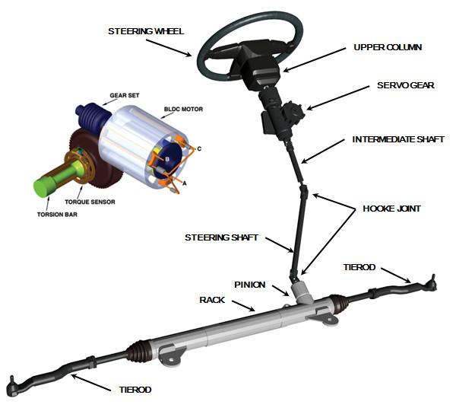

Figure 2 Components of a steering system with Electric Power Steering

Electric power steering systems provide numerous benefits over hydraulic systems, including improved fuel economy, flexibility for advanced functions and compact motor packages. Through precise control of an electric motor and sophisticated electronic controls, EPS aims to optimize steering assistance, dynamics and safety while reducing emissions from unnecessary hydraulic pump operation.

Electric power steering (EPS) systems have become a standard feature in modern vehicles to assist the driver and improve driving comfort. EPS uses an electric motor to generate the power that assists the driver's input torque on the steering wheel. Through precise control algorithms and rules, EPS enables features like variable assistance based on vehicle speed and self-centering when driving in a straight line. These systems aim to provide optimum balance between steering feel, maneuverability, and safety.

When a vehicle moves on different trajectories, at different operating conditions, the driver must apply the necessary driving force. And currently, the urgent need is to increase the controllability and reduce of steering effort of the driver while driving. Depending on the different states of motion, the electric power steering system (EPS) needs to provide the necessary assist steering torque. In order for the assist electric motor to operate effectively and efficiently, it is necessary to have a appropriate control rules to ensure that the motor will operate as required and save energy. Therefore, the graduation project thesis: "Simulation of the law of power motor control of EPS electric steering system on MATLAB Simulink/Simscape" is an important and significant research topic in the research and development of EPS electric steering system.

The simulation and design of control rules on MATLAB Simulink/Simscape will allow engineers and researchers to evaluate and optimize the performance of EPS electric steering systems before actual deployment. In addition, the project also brings knowledge of electrical theory, control theory and skills in using MATLAB Simulink/Simscape software to simulate and design electronic systems. Simulation of EPS control rules plays an important role in the development and optimization of these systems. Computer simulations allow testing of different control strategies and parameters in a virtual environment before expensive physical prototypes are built. This greatly reduces development time and costs by eliminating trial-and-error experimentation using real hardware. Computer models of EPS systems can accurately emulate the dynamic behavior and interactions between the various system components.

There are several types of EPS widely used on production cars:

* Column EPS
* Single-Pinion EPS
* Dual-Pinion EPS
* Parallel Axis EPS

This project will simulate the control rules of Column EPS in Simulink and Simscape.

In summary, this thesis report aims to build a simulation model of an EPS system to fully understand how the system works and behaves in different working conditions. The model will consist of mechanical components of steering system with electric motor, torque sensor, and EPS control unit.

## **1.2 Introduction to Simulink and Simscape**

Simulink is a block diagram environment for multidomain simulation and Model-Based Design. It supports system-level design, simulation, automatic code generation, and continuous test and verification of embedded systems. Simulink provides a graphical editor, customizable block libraries, and solvers for modeling and simulating dynamic systems. It is integrated with MATLAB, enabling we to incorporate MATLAB algorithms into models and export simulation results to MATLAB for further analysis.

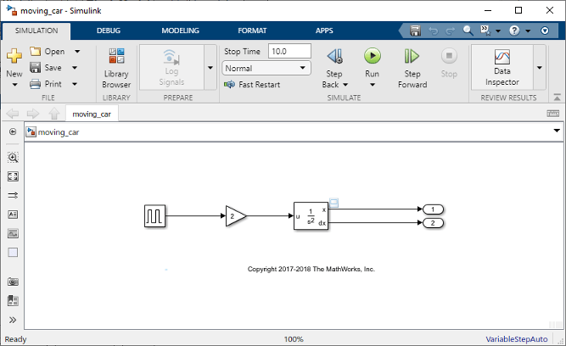

Figure 3 Sinulink user interface

Simscape enables we to rapidly create models of physical systems within the Simulink environment. With Simscape we build physical component models based on physical connections that directly integrate with block diagrams and other modeling paradigms. We model systems such as electric motors, bridge rectifiers, hydraulic actuators, and refrigeration systems by assembling fundamental components into a schematic. Simscape add-on products provide more complex components and analysis capabilities. Simscape helps we develop control systems and test system-level performance. We can create custom component models using the MATLAB based Simscape language, which enables text-based authoring of physical modeling components, domains, and libraries. We can parameterize our models using MATLAB variables and expressions, and design control systems for our physical system in Simulink. To deploy our models to other simulation environments, including hardware-in-the-loop (HIL) systems, Simscape supports C-code generation.

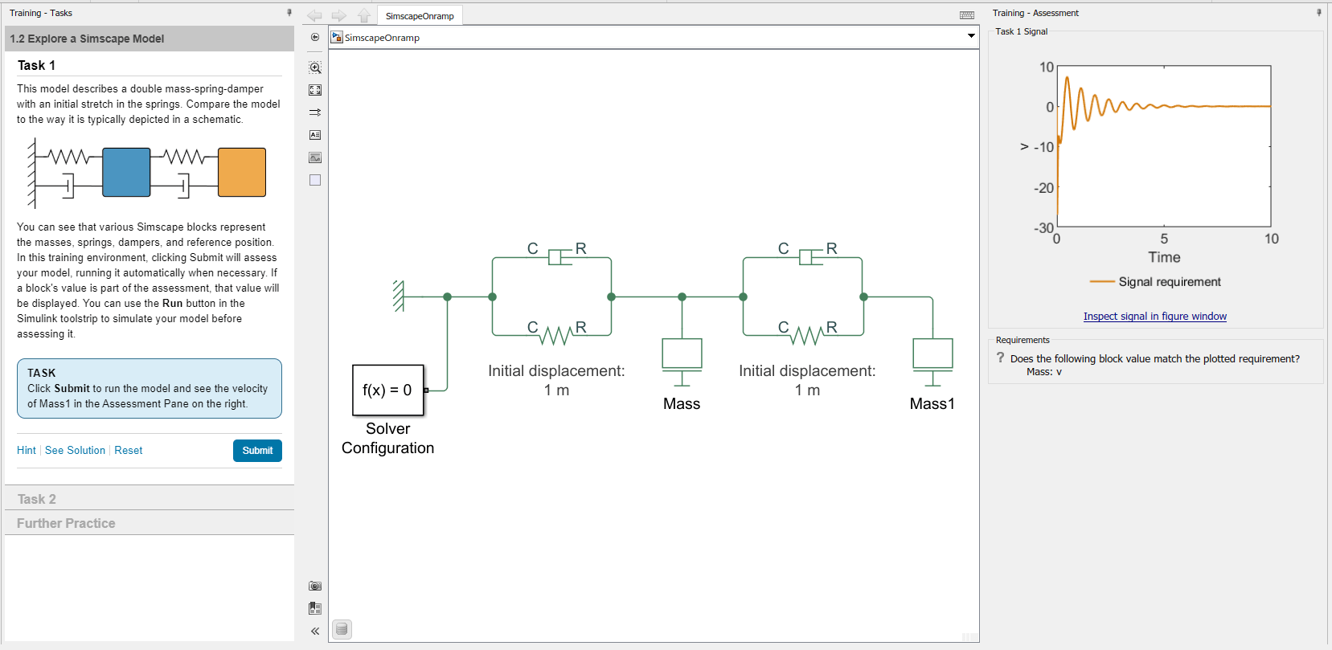

Figure 4 Simscape user interface

Overview of MATLAB/Simulink:

|  |  |  |  |
| --- | --- | --- | --- |
| **Tools** | **Definition** | **Application** | **Advantages** |
| MATLAB | MATLAB is a numerical computing and programming environment widely used in fields such as science, engineering, mathematics, and research. MATLAB provides a powerful programming language and a range of integrated tools and functions for performing tasks such as computation, data processing, visualization, simulation, and numerical analysis. | + Programming languages  + Numerical computing tools  + Data visualization and simulation  + Data processing and analysis  + Integration with other tools: MATLAB also supports integration with hardware devices and other programming tools such as C/C++, Python, Java. | + Provides interactive features that allow users to manipulate data flexibly in the form of matrix arrays for computation and observation.  + Offers fast and accurate computations for numerical analysis.  + Has a high-level programming language that is more human-readable compared to other programming languages.  + Supports integration with other tools and hardware devices, such as C/C++, Python, Java, and more.  + Provides data visualization and simulation capabilities.  + Offers data processing and analysis tools. |
| Simulink | MATLAB Simulink is a graphical simulation and modeling software integrated within the MATLAB environment. It provides a graphical interface for designing, simulating, and analyzing dynamic and control systems. | Simulink allows users to build graphical system models by using functional blocks and connecting them together to form a complete model. Simulink supports simulation and modeling of systems in various fields, including electrical, electronics, mechanical, control systems, signal processing, and many others. Users can simulate and test system models, evaluate performance and stability. | Simulink has tight integration with MATLAB. Users can use MATLAB's computational and analytical tools to work with input data and results from Simulink models, as well as create and customize their own functions and algorithms. This integration allows for a more comprehensive and seamless workflow in designing and analyzing complex systems. |

## **1.3 Project Objectives**

The objectives of the project are to solve the simulation model of the control rules of Electric Power Steering system using MATLAB/Simulink/Simscape and integration with steering system and vehicle body dynamics model.

The contents need to be done of this project are:

* Summary theoretical basis of EPS system
* Simulate the model and control of electric motor
* Simulate the model and control rules of EPS system in Simulink and Simscape
* Evaluate the results of assisting torque in different operating conditions of the vehicle (speed, steering wheel angle)

## **1.4 Working conditions**

* The Electric power steering (EPS) system works when the vehicle is moving in any path and different operating conditions at different speeds.
* The assist electric motor rotates in different load modes.

## **1.5 Technical requirements**

* Simulation model works properly
* Accurate control rules of EPS system
* Vehicle can follow a desired path

## **1.6 Limitation**

This project mainly focuses on the control rules of EPS system and ignores the electrical connections among electric components.

# **II. THEORETICAL BASIS**

## **2.1 Overall Structure and Working Principles of EPS System**

### **2.1.1 Overall structure**

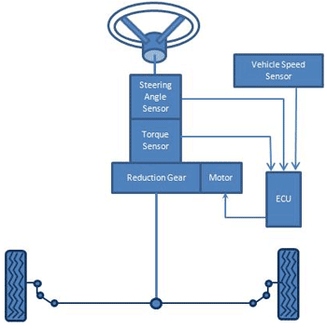

Figure 5 EPS structure

An electric power steering system is basically a steering system with additional components (mostly electric):

* Steering wheel: a control mechanism located in the cockpit
* Steering shaft: connecting the steering wheel and steering mechanism
* Steering mechanism: a gear reducer mounted on the frame or chassis of the car
* Steering actuator: is a set of driving structures from the steering mechanism to the guide wheels and the links between the guide wheels.
* Torque sensor:

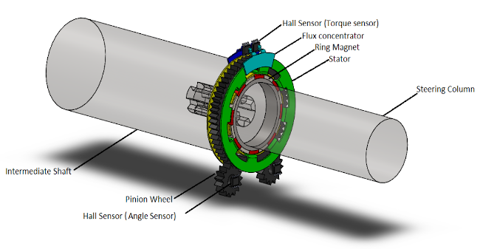

Figure 6 Torque sensor of EPS

It is a device used in electric power steering systems to measure the torque applied by the driver to the steering wheel. By calculating this data, the electronic control unit determines how much steering assistance to apply to the electric motor.

The torque sensor consists of input and output shafts connected by a torsion bar. The input shaft has splines, while the output shaft has slots. By moving the input and output shafts, torque is created in the torsion bar, which is magnetized and then converted into voltage.

* Steering angle sensor:

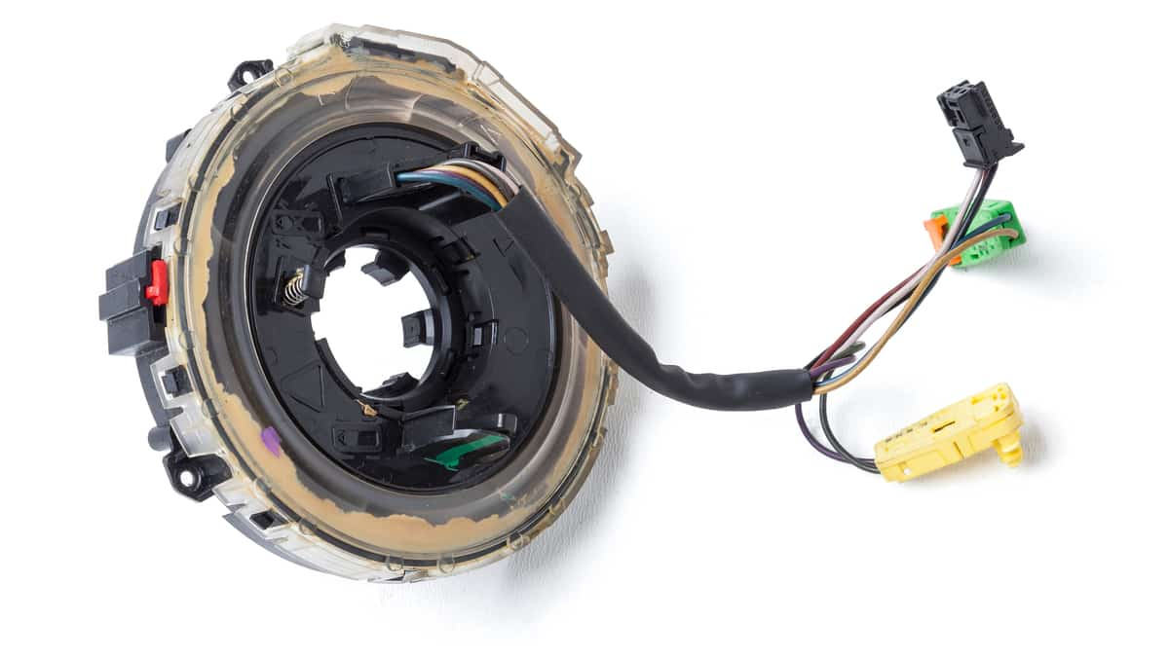

Figure 7 Steering angle sensor of EPS

It measures the position angle and rate of turn of the steering wheel. It matches the steering wheel with the vehicle’s wheels to determine where the driver wants to steer. Steering angle sensors are mounted in the steering column of a vehicle. In an EPS system, more than one angle sensor is used to provide redundancy and data verification. Nowadays, the torque sensor can also give information about the steering wheel angle so this sensor might not be necessary.

* EPS control unit (ECU):

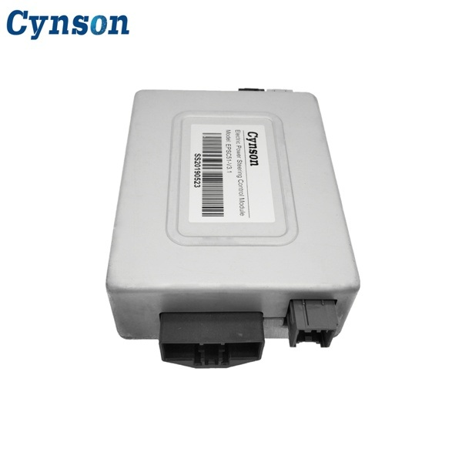

Figure 8 Control module of EPS

The control module is responsible for managing the operation of the electric motor. It receives input signals from various sensors and the vehicle's electronic control unit (ECU) and sends output signals to the motor.

The control module uses complex algorithms to determine the amount of steering assistance required based on the driver's input, vehicle speed, and other factors. It adjusts the electric motor's power output accordingly to provide the right amount of steering assistance.

* Electric motor (assist motor)

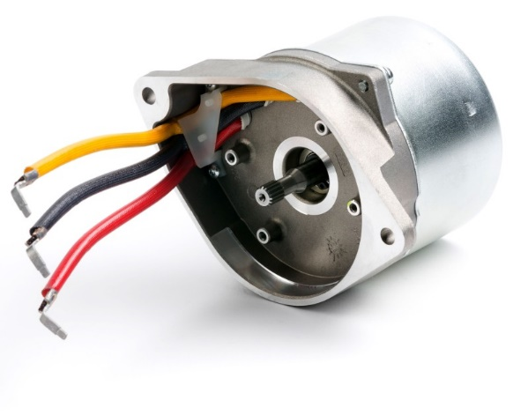

Figure 9 Electric motor of EPS

The electric motor is the heart of an EPS system. It generates the power needed to assist the driver in steering the vehicle. The motor is usually located on the steering column or the steering rack, and it is controlled by the system's control module.

Most electric power steering systems use a three-phase electric motor powered by a pulse width modulated DC voltage. The motor is brushless and has an operating voltage range of 9 to 16 volts. Three-phase motors allow for faster and more precise application of torque at low RPMs.

* Reduction gear

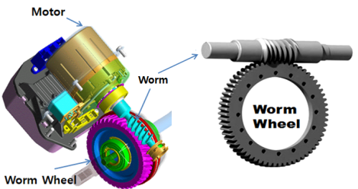

Figure 10 Reduction gear of EPS

When the steering wheel is returned from large steering efforts, such as when turning in an intersection, this reduction gear provides smooth steering corrections as well as improved comfort when the steering wheel is returned from large steering efforts, like when turning in straight lines.

### **2.1.2 Working principles**

The working principle of an Electric Power Steering (EPS) system is based on the use of an electric motor to provide steering assistance to the driver. The EPS system operates by continuously monitoring the driver's steering input and vehicle speed and applying an appropriate amount of steering assistance to help the driver turn the wheels.

When the driver turns the steering wheel, the control module uses the torque sensor data to calculate the amount of assistance required from the electric motor. The control module then sends a signal to the electric motor, which applies the appropriate amount of assistance to the steering system. The electric motor can be located on the steering column or rack, and it can provide direct assistance to the steering system or operate a belt-driven system that helps from a remote location.

## **2.2 Dynamic Equilibrium Equations of EPS System**

The dynamic equilibrium equations of a system are a set of mathematical equations that describe the motion and behavior of the system over time. These equations are used to determine how the system will respond to external forces and inputs, and they are essential for understanding the stability and performance of the system.

The function of the dynamic equilibrium equations is to establish a relationship between the forces acting on the system and the resulting motion and behavior of the system. These equations consider the mass, velocity, acceleration, and other physical properties of the system, as well as the external forces and inputs that are acting on it.

By using the dynamic equilibrium equations, engineers and scientists can simulate the behavior of a system under different conditions and inputs and can optimize the system's performance and stability. These equations are also essential for designing and testing new systems, and for troubleshooting problems in existing systems. Overall, the dynamic equilibrium equations are a fundamental tool for understanding and controlling the behavior of complex systems in a wide range of applications.

Figure 11 EPS structure

To formulate the equilibrium equation of the electric power steering system, we divide the system into mechanical and electrical components, respectively:

Consider the equilibrium of the steering input shaft (from steering wheel to torsion bar input):

Figure 12 EPS structure (from steering wheel to torsion bar input)

With

**🡺**

Consider the equilibrium at the rotor shaft of the electric motor:

Figure 13 EPS structure (Rotor shaft of the motor)

* Electrical equation
* Mechanical equation

With

**🡺**

Consider the equilibrium at the output steering shaft (from the torsion bar output to the steering mechanism):

Figure 14 EPS structure (from the torsion bar output to the steering mechanism)

With

**🡺**

With

- Voltage supply to the motor (V)

- Armature current (A)

- Armature coil resistance (Ohm)

- Armature coil inductance (H)

- Motor electromagnetic constant (V/(rad/s))

- Motor torque constant (Nm/A)

- Angle of rotation of the rotor shaft of the motor (rad)

- Angular speed of rotor shaft of the motor (rad/s)

- Angular acceleration of rotor shaft of the motor (rad/)

- Moment of inertia of the motor (kg. *)*

- Friction coefficient of motor (Nm/(rad/s))

- Torque generated from armature coil (Nm)

- Friction torque of torque (Nm)

- Power assist torque before gear (Nm)

- Power assist torque after gear (Nm)

- Steering wheel angle (rad)

- Driver torque (Nm)

- Friction torque between the steering wheel and steering column (Nm)

- Steering wheel friction coefficient (N.m/(rad/s))

- Moment of inertia of the steering wheel (kg. *)*

- Torsion bar stiffness (Nm/rad)

- Torque on the torsion bar (Nm)

- reduction gear ratio

- Torque on the lower steering column (Nm)

- Friction torque on the lower steering column (Nm)

- Friction coefficient of lower steering column (Nm/(rad/s))

- Moment of inertia of lower steering column (kg. *)*

- Angle of rotation of lower steering column (rad)

- Resistant torque at the pinion (Nm)

: Vehicle speed (m/s)

## **2.3 Overall Diagram and Control Rules of EPS System**

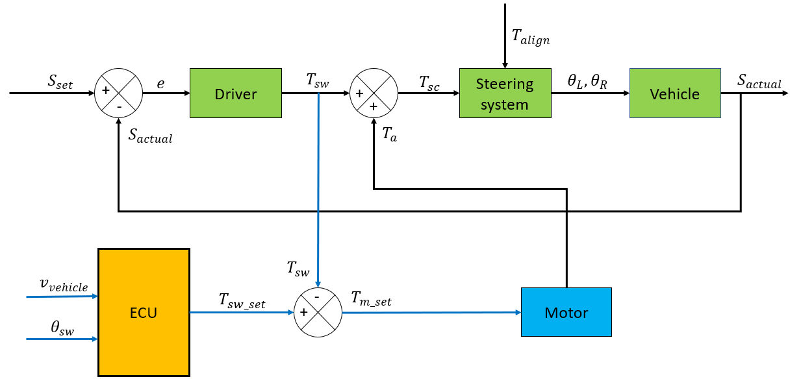

Figure 15 EPS block diagram

In order to simulate the control rules of EPS, a driving situation is created. A PID controller will play the role of the driver. It will receive the error signal between the set path and the actual path to adjust the torque acting on the steering wheel of the steering system. From there, the steering system block will give out the signals of left and right wheels angles to vehicle block. The vehicle block will move and feedback the actual moving direction.

The torque the driver exerted on the steering wheel will be compared with the steering limits which will be calculated based on the steering wheel angle and speed of the vehicle. If it exceeds the limit, the motor’s PID controller will receive the error signal between the torques and gives out voltage signal to control the motor to create the assisting torque.

## **2.4 PID Controller**

PID (Proportional Integral Derivative) controller is a combination of three controllers:  
proportional, integral, and differential, capable of adjusting to the lowest possible error, increasing response speed, reducing overshoot, and limiting oscillation. The PID controller is a process control technique that engages in “proportional, integral, and differential” processing actions. That is, the resulting error signals will be minimized by the effect of the proportional effect, the effect of the integral effect and clarified by a rate obtained with the fractional effect before.

* P: It is a proportional adjustment method, which helps to generate an adjustment signal proportional to the input error according to the sampling time.
* I: Is the integral of the error over the sampling time. Integral control is a tuning method to generate tuning signals so that the error is reduced to 0. This tells us the total instantaneous error over time or the accumulated error in the past. The smaller the time, the stronger the integral adjustment effect, corresponding to the smaller deviation.
* D: Is the differential of the error. The differential control generates an adjustment signal that is proportional to the rate of change of the input bias. The larger the time, the stronger the differential tuning range, which corresponds to the faster the regulator responds to input changes.

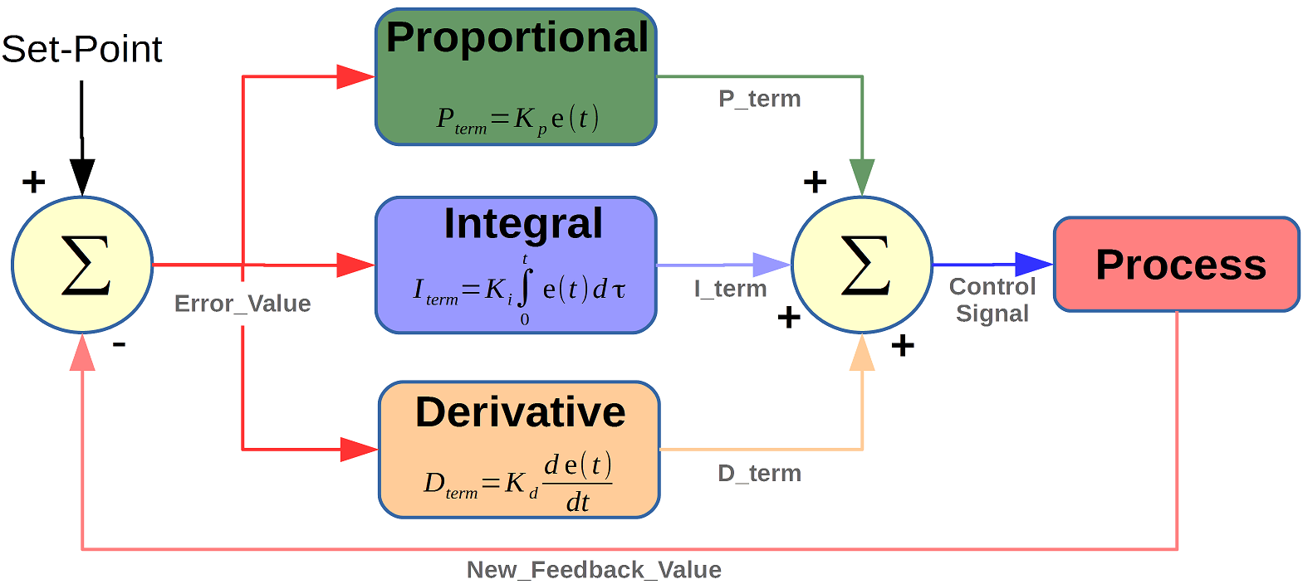

Figure 16 A PID controller structure

While being widely used in various industrial process with many advantages, there are some limitations

Advantages:

* PID controllers are simple and versatile, making them suitable for a wide range of systems.
* They can be easily implemented and applied to various control tasks with relatively little effort.
* PID controllers can be tuned to achieve stable and accurate control, making them effective in systems with slowly changing dynamics.
* Their continuous output enables them to respond quickly to changes in the system.
* PID controllers can be modified to meet specific requirements by adjusting the gain parameters, offering flexibility in system design.

Disadvantages

* PID controllers are sensitive to noise and disturbances, which can lead to instability and degraded performance.
* Tuning PID controllers can be challenging, particularly for complex systems with nonlinear or time-varying dynamics.
* They are not suitable for controlling systems with fast dynamics or high-frequency noise.
* Due to the lack of a system model, diagnosing problems and making improvements can be difficult.

In this project, PID controller will be used as a driver and a controller for electric motor.

# **III. SIMULATION PROCESS**

## **3.1 Creating A Path for The Vehicle**

As previously stated, to accurately model the control rules of an electric power steering system, it is imperative to create a realistic driving scenario that involves the driver turning the steering wheel to the left or right. Therefore, the driving scenario will be lane changing.

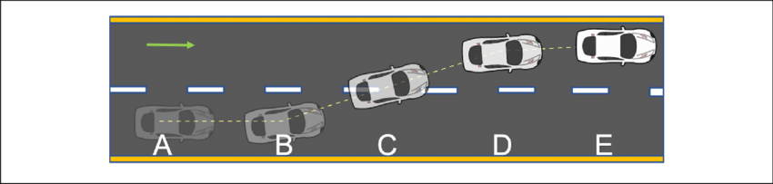

Figure 17 A driving scenario - lane changing

To create this driving scenario, the vehicle motion needs to be tracked so that the driver can adjust the steering wheel so that the vehicle will move in a preset path. This motion can be controlled by considering the displacement of the vehicle along x and y axis of the earth-fixed coordinate. However, as a PID controller will be used as a driver, it cannot control both variables (x and y displacement), so we need a variable that can present the displacement of the vehicle according to both x and y. As a result, heading angle of the vehicle will be the variable to be controlled.

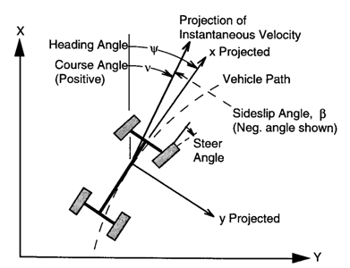

Figure 18 Heading angle of a vehicle

Heading angle of a vehicle is the angle between the moving direction and a fixed reference point, which in this driving scenario will be the x axis. In other words, it is the direction in which the vehicle is traveling relative to x axis. This heading angle will be calculated by as yaw (rad) a MATLAB block - Vehicle Body 3DOF, which will be described later.

Figure 19 Position of the Set Path block in the model

Figure 20 Structure of Set Path block

Heading angle will be calculated as:

With

– heading angle of vehicle (rad or degree)

– speed of vehicle along x-axis of earth coordinate (m/s)

– speed of vehicle along y-axis of earth coordinate (m/s)

From the above formula, we first create a table consisting of x and y coordinates of the car over time. Then, divide derivative of y by derivative of x to obtain the heading angle. From there, we have a lookup table of heading angles corresponding to each x coordinate of the vehicle.

From the original position where the car travels the dx distance, we will get a new x coordinate, now through the above lookup table, the heading angle is obtained. Use the new heading angle to calculate the new dx distance and repeat, similar to y. As a result, for each dx and dy, we will find the set heading angle for the car.

According to the coordinate system of the Vehicle Body 3DOF block in MATLAB, the vehicle will start moving in the direction x so x will be the path and y will be the distance between the 2 lanes. At different speeds, the distance x will increase or decrease to match reality. Y will have a maximum value of 3.5 because this is a standard width of a lane.

At higher speed, the X displacement needs to lengthen so that the set heading angle is lowered, avoid the situation of hard cornering for the vehicle.

At 10km/h

Figure 21 Set path of vehicle at 10km/h

Figure 22 Set heading angle of vehicle at 10km/h

At 40 km/h:

Figure 23 Set path of vehicle at 40km/h

Figure 24 Set heading angle of vehicle at 40 km/h

At 80 km/h:

Figure 25 Set path of vehicle at 80 km/h

Figure 26 Set heading angle of vehicle at 80 km/h

## **3.2 Driver Block**

To simulate the driver, simply use a PID controller.

Figure 27 Position of driver block in the model

It will receive the actual heading angle of the vehicle and output the steering torque to the steering system block. The P, I, D coefficients of this controller should be chosen correctly so that it can behave closest to a human.

Figure 28 Structure of Driver block

## **3.3 Steering System**

Figure 29 Position of Steering system block in the model

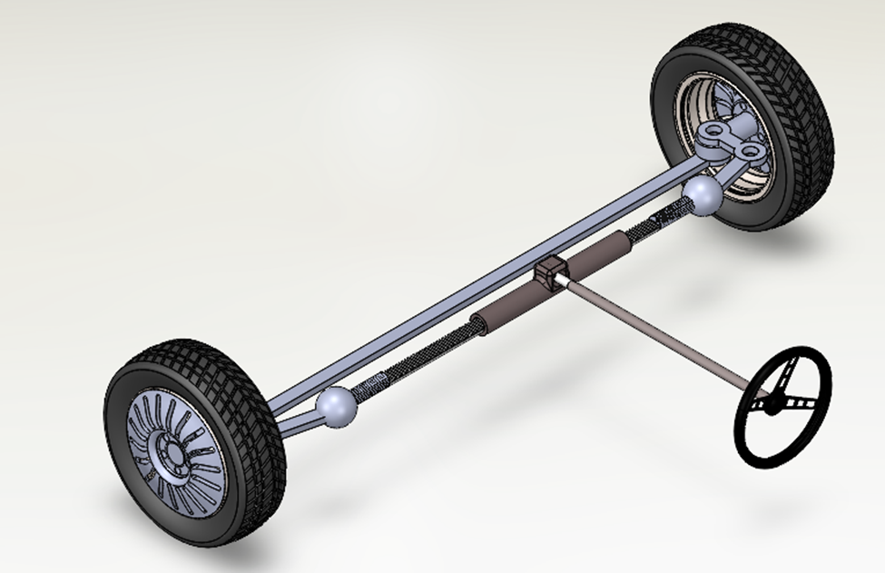

Figure 30 The complete 3D model of steering system

This block will represent the mechanical components of steering system of the vehicle such as steering wheel, steering column, rack and pinion, tie rod, and wheels. This block is from the project - Analysis, 3D modeling and dynamic simulation of the vehicle steering system in the VIOS car. This block will also take into account the resistance torque from the wheels from the project - Modeling and simulation the resistance torque for specific wheel alignment in the Electric Power Steering system by using Matlab/Simulink and its application. To summary, the input and output of this block are shown as below:

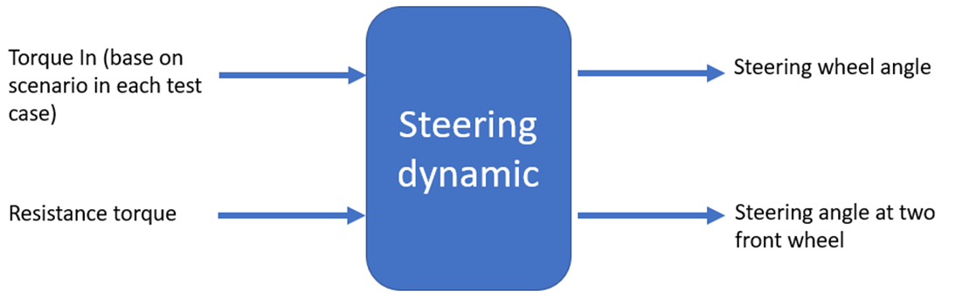

Figure 31 Inputs and outputs of steering system block

## **3.4 Vehicle Model**

To simulate the vehicle motion, we will use the Vehicle Body 3DOF block. The Vehicle Body 3DOF block implements a rigid two-axle vehicle body model to calculate longitudinal, lateral, and yaw motion. The block accounts for body mass and aerodynamic drag between the axles due to acceleration and steering.

Figure 32 Position of Vehicle Body 3DOF block in the model

In the Vehicle Dynamics Blockset™ library, there are two types of Vehicle Body 3DOF blocks that model longitudinal, lateral, and yaw motion.

* Vehicle Body 3DOF Single Track

Figure 33 Vehicle Body 3DOF Single Track block

* + Forces act along the center line at the front and rear axles.
  + No lateral load transfers.
* Vehicle Body 3DOF Dual Track

Figure 34 Vehicle Body 3DOF Dual Track block

* + Forces act at the four vehicle corners or hard points

To simulate precise vehicle model, we will the later type - Vehicle Body 3DOF Dual Track.

The function of this block in our system are to calculate these variables:

* X and Y displacement of the vehicle along earth fixed coordinate: these variables are needed to plot the actual path of the vehicle.
* Yaw angle: this is the heading angle of the vehicle that will be feedback to the driver to adjust the steering torque.

## **3.5 Electric Motor Model**

An electric motor is a device that converts electricity into mechanical energy. It has a simple structure and is popular in industrial usage. In EPS system, DC motor will be mounted directly on the steering column, and it will provide assist torque according to the signal from the ECU.

In this part, a motor model is built and controlled in MATLAB/Simulink. This model will allow users to understand and evaluate the behaviors and output responses of the motor. As mentioned in the beginning of this report, this project will not focus on the simulation of electrical components of the motor and its efficiency. Therefore, there are two methods of simulation as below:

* Using dynamic equations of DC motor
* Using DC Machine block in MATLAB Simulink

🡺 The outcomes of two models will be compared and evaluated to verify them.

**3.5.1 Simulation of electric motor**

- Using dynamic equations of DC motor:

The dynamic equations of DC motor will be constructed based on the electric equivalent circuit of the armature and the free-body diagram of the rotor:

Figure 35 Electric equivalent circuit of the armature and the free-body diagram of the rotor

With:

**v** - Voltage supply to the motor (V)

**e** - Induced voltage (V)

**I** - Armature current (A)

**R** - Armature resistance (Ohm)

**L** - Armature inductance (H)

- Motor electromagnetic constant (V/(rad/s))

- Motor torque constant (Nm/A)

- The angle of rotation of the rotor shaft of the motor (rad)

- Rotor shaft angular speed of the motor (rad/s)

- rotor shaft angle acceleration of the motor (rad/)

**b** - Motor friction coefficient (Nm/(rad/s))

- Armature moment (Nm)

- Motor friction torque (Nm)

**J** - Motor moment of inertia (kg.)

The parameters of the motor used in this simulation model:

Table 1 Parameters of motor

|  |  |  |  |
| --- | --- | --- | --- |
| Symbols | Parameter | Unit | Value |
| R | Armature coil resistance | Ohm | 0.6 |
| L | Armature coil inductance | H | 0.002 |
| U | Power supply voltage | V | 36 |
|  | Motor friction coefficient | Nm/(rad/s) | 0.071 |
|  | Motor moment of inertia | kg. | 0.00218907 |
|  | Motor electromagnetic constant | V/(rad/s) | 0.3533 |
|  | Motor moment constant | Nm/A | 0.456 |

From the figure above, we can derive the following governing equations based on Newton's 2nd law and Kirchhoff's voltage law.

* Electrical equations:
  + Armature voltage :
  + Motor voltage:
* Mechanical equation:

With

🡺 Assist torque from the motor:

From the equations above, a model in MATLAB/Simulink can be built

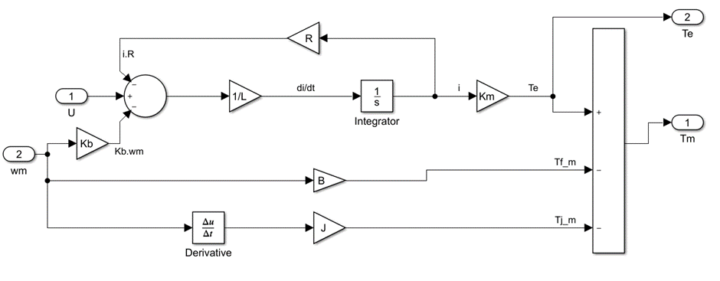

Figure 36 DC motor model using dynamic equations

- Using DC Machine block from MATLAB/Simulink

Beside the mathematics method, MATLAB/Simulink offers various built-in models of the motor. And the block is used in this project is DC Machine from the library Simscape / Electrical / Specialized Power Systems / Fundamental Blocks / Machines.

Figure 37 DC Machine block in MATLAB/Simulink

The DC Machine block implements a wound-field or permanent magnet DC machine. DC Machine blocks have stators (inductors) and rotors (armatures). Inductors and inductors in DC Machine blocks can be supplied by separate voltage sources (i.e., separate excitations) or from the same source (i.e., self-excitation). With the permanent magnet lava type, it is only necessary to power the coil.

The complete model using this block is as below

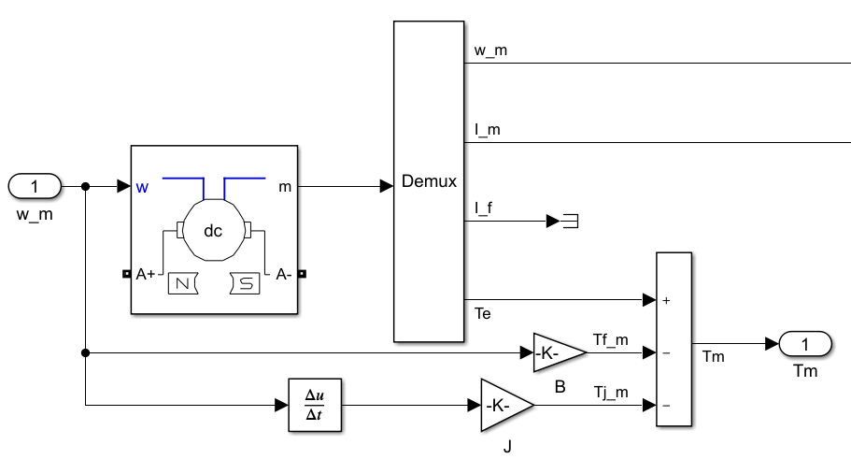

Figure 38 DC motor model using DC Machine block

**3.5.2 Control of electric motor**

The motor models are implemented into a closed-loop system using PID controller as the diagram below:

Figure 39 Control diagram of electric motor

And the models in MATLAB/Simulink

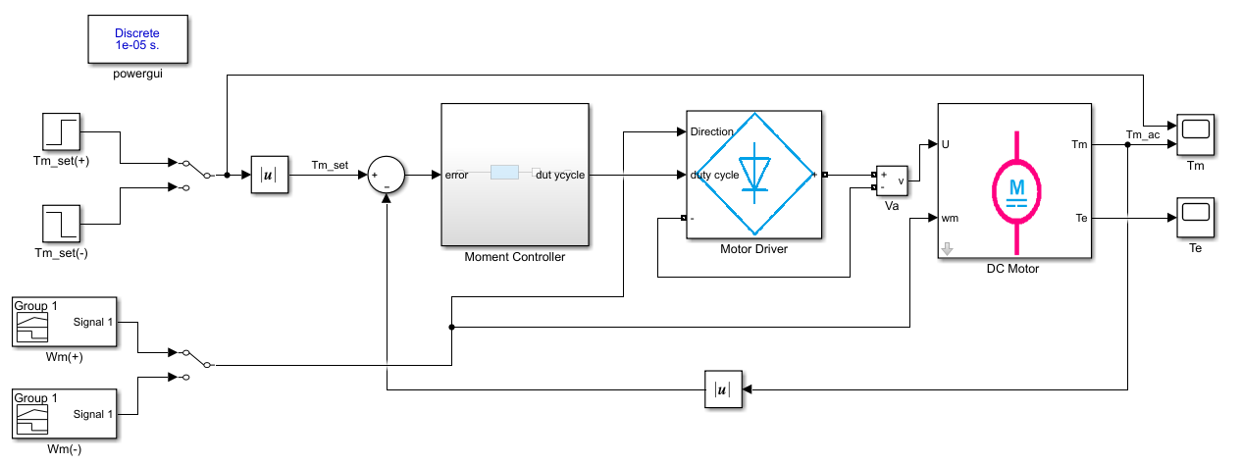

Figure 40 Control model of DC motor model using dynamic equations

Figure 41 Control model of DC motor model using DC Machine block

The models will be run the set torque of 10Nm in both directions (clockwise and counterclockwise) in 10s.

Tuning the PID controller: To achieve highest efficiency, of the PID controller will be chosen by PID tuner of MATLAB Simulink

Figure 42 PID Tuner app user interface in MATLAB/Simulink

🡺 The coefficients are:

The results of the two models:

- Clockwise direction:

Figure 43 Output response of DC motor model using dynamic equations

Figure 44 Output response of DC motor model using DC Machine block

- Counterclockwise direction

Figure 45 Output response of DC motor model using dynamic equations

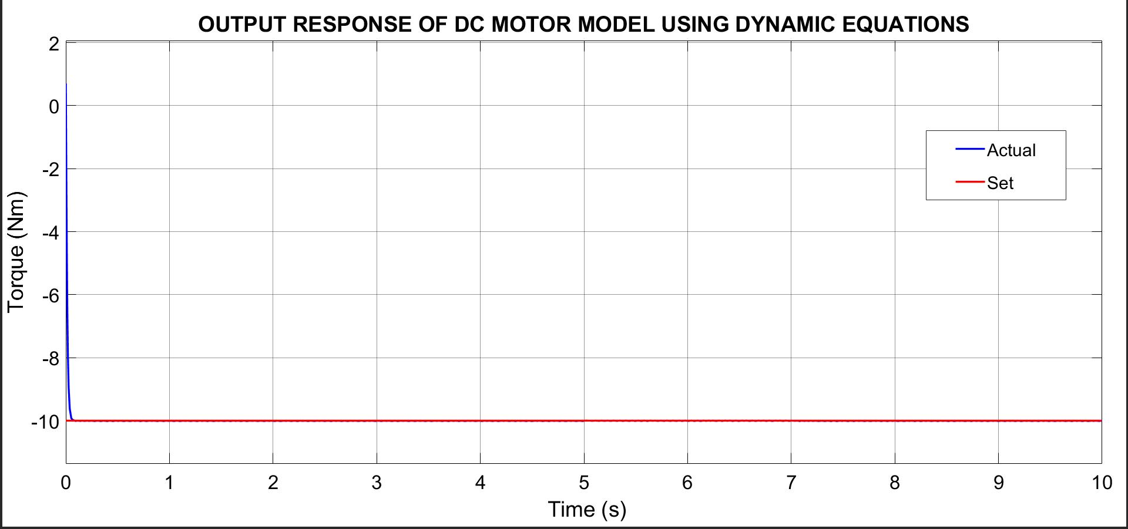

Figure 46 Output response of DC motor model using DC Machine block

Conclusion:

* Both models have the same and similar results, therefore both models are correct
* The output response of both models are highly accurate and fast with little error and almost no overshoot
* Both models can rotate in either direction

🡺 Either model can be used in the complete model of the EPS system

# **IV. SIMULATION RESULTS AND EVALUATION**

Figure 47 Overall structure of the model

Start to run the model at different set paths, at different speeds at mentioned above. Track the data of steering input torque, assist torque, steering wheel angle, heading angle and displacement in x and y axis of earth coordinate, and compare them with and without EPS.

**4.1 At Set Path 10km/h**

Figure 48 Driver steering torque at set path 10km/h

Figure 49 Steering wheel angle at set path 10km/h

The figure comparing the steering driver torque with and without EPS presents a compelling case for the use of EPS in modern vehicles. The plot clearly demonstrates that the use of EPS results in significantly lower torque requirements for the driver, which translates to improved comfort and safety behind the wheel.

The plot itself shows two curves, one for the torque required with EPS and the other for the torque required without EPS. The x-axis represents the steering angle, while the y-axis represents the steering driver torque. The curve for the torque required without EPS is consistently higher than the curve for the torque required with EPS, indicating that the driver needs to exert more force on the steering wheel to achieve the same level of steering effort without EPS.

This difference in torque required is most pronounced at low steering angles, where the torque required without EPS is almost twice that required with EPS. This finding has significant implications for driver comfort and safety, as it suggests that vehicles equipped with EPS are easier and less fatiguing to steer, especially at low speeds.

While the figure comparing the steering driver torque with and without EPS provides a clear visual representation of the torque requirements, it may not be immediately apparent to the reader how this translates to energy expended by the driver. However, it is possible to calculate the energy expended by the driver using the torque and angular displacement data presented in the figure.

By multiplying the torque required by the driver at each steering angle by the corresponding angular displacement, it is possible to calculate the work done by the driver. Dividing the work by the time taken to complete the steering maneuver allows for the calculation of the power expended by the driver, which is a measure of the energy expended per unit of time.

This approach provides a more quantitative measure of the energy expended by the driver and can help to better illustrate the differences between the with and without EPS conditions. For example, it may be found that the power expended by the driver is significantly lower when using EPS, indicating that the driver is expending less energy to achieve the same level of steering effort.

Furthermore, presenting this data alongside the torque and angular displacement data in the form of a table or additional graph can help to provide a more complete picture of the differences between the two conditions. This approach can also facilitate more detailed analysis of the data, such as the calculation of efficiency metrics such as mechanical efficiency, which can provide further insights into the performance of the steering system under different conditions

* Without EPS: 17.92 (J)
* With EPS: 15.97 (J)

🡺 The EPS control algorithm is correct as it helps decrease the energy needs to expend.

**4.2 At Set Path 40km/h**

Figure 50 Driver steering torque at set path 40km/h

Figure 51 Steering wheel angle at set path 40km/h

At higher speeds, the driver steering torque is typically higher due to the increased stability and resistance of the vehicle, which requires more effort from the driver to turn the steering wheel. As a result, the assistance torque from the EPS may be reduced to prevent over-assistance and maintain a natural and responsive steering feel.

Regarding the steering wheel angle, the amount of assistance provided by the EPS may also vary depending on the angle of the steering wheel. For example, EPS systems may provide more assistance at low steering wheel angles to make it easier for drivers to maneuver in tight spaces, while providing less assistance at higher steering wheel angles to maintain vehicle stability and prevent over-steering.

🡺 At higher speed, reduce the assistance

# **V. CONCLUSION**

From the results above, the driver steering torque limit can be described as below:

Figure 52 Driver steering torque limits

Compare with the control algorithm from the article - A New Control Strategy of an

Electric-Power-Assisted Steering System:

Figure 53 Driver steering torque limits from the article - A New Control Strategy of an Electric-Power-Assisted Steering System

The simulation and modeling of this project’s control rules for EPS systems have also shown that the assistance provided to the driver is inversely proportional to the vehicle's speed. That is, the lower the speed, the higher the assistance, and vice versa. This is because at low speeds, such as during parking or maneuvering in tight spaces, the driver requires more assistance to turn the wheels and maneuver the vehicle. Conversely, at higher speeds, the driver requires less assistance to maintain control of the vehicle, and the EPS system provides less assistance. The simulation results confirm the behavior of real-world EPS systems, indicating that the model accurately replicates the control algorithm used in EPS systems.

Electric power steering (EPS) systems have become a standard feature in modern vehicles due to their many advantages, including improved fuel efficiency, reduced CO2 emissions, and increased reliability. EPS systems use an electric motor to aid the driver, which is determined by the vehicle's speed and steering angle. The simulation and modeling of control rules for EPS systems are crucial for the development of advanced driver assistance systems (ADAS) and autonomous driving technologies.

In addition to speed, EPS systems provide variable assistance based on the steering angle. The simulation and modeling of control rules for EPS systems have shown that the assistance provided by the EPS system is directly proportional to the steering angle. This means that the higher the steering angle, such as during a sharp turn, the higher the assistance provided by the EPS system, and vice versa. This variable assistance allows for smoother and more intuitive steering, which improves the driving experience and reduces driver fatigue.

The accuracy and realism of the simulation model can be enhanced by incorporating data from real-world driving scenarios and testing conditions. This could help to improve the predictive capabilities of the model, allowing for more accurate and reliable simulations of different driving scenarios. Furthermore, the development of new control rules and algorithms for EPS systems could help to further optimize the performance and efficiency of these systems. For example, advanced control algorithms could be developed to provide even more precise and intuitive steering, or to optimize the balance between driver assistance and vehicle stability.

The correct control algorithm is essential for the safe and reliable operation of EPS systems in different driving scenarios. The simulation and modeling of control rules for EPS systems is an important area of research that has the potential to contribute to the ongoing development of advanced vehicle technologies and improve the safety and performance of vehicles on the road. As technology advances, the simulation and modeling of control rules for EPS systems will continue to evolve, with new algorithms and control rules being developed to improve the accuracy and reliability of the simulations.

In conclusion, the simulation and modeling of control rules for EPS systems have demonstrated that the assistance provided to the driver is dependent on vehicle speed and steering angle, with higher assistance provided at lower speeds and higher steering angles. The accurate simulation of EPS systems is crucial for the development of ADAS and autonomous driving technologies. The correct control algorithm is essential for the safe and reliable operation of EPS systems in different driving scenarios. The development of advanced control algorithms and the incorporation of real-world data into the simulation model can further enhance the accuracy and realism of the model. Overall, the simulation and modeling of control rules for EPS systems is an important area of research that has the potential to contribute to the ongoing development of advanced vehicle technologies and improve the safety and performance of vehicles on the road.

# **VI. FUTURE WORK AND ENHANCEMENTS**

The simulation and modeling of the control rules of electric power steering systems are crucial for the development of advanced driver assistance systems (ADAS) and autonomous driving technologies. As such, future work on this project could involve enhancing the accuracy and realism of the simulation model by incorporating data from real-world driving scenarios and testing conditions. This could help to improve the predictive capabilities of the model, allowing for more accurate and reliable simulations of different driving scenarios. Additionally, the development of new control rules and algorithms for EPS systems could help to further optimize the performance and efficiency of these systems. For example, advanced control algorithms could be developed to provide even more precise and intuitive steering, or to optimize the balance between driver assistance and vehicle stability. Overall, the future work and enhancement of this project has the potential to contribute to the ongoing development of advanced vehicle technologies and improve the safety and performance of vehicles on the road.

# **VII. REFERENCE**

1. R. -O. Nemes, M. Ruba and C. Martis, "Integration of Real-Time Electric Power Steering System Matlab/Simulink Model into National Instruments VeriStand Environment," 2018 IEEE 18th International Power Electronics and Motion Control Conference (PEMC), Budapest, Hungary, 2018, pp. 700-703, doi: 10.1109/EPEPEMC.2018.8521888.
2. Hiremath, R. R., & Isha, T. B. (2019, October 1). Modelling and simulation of electric power steering system using permanent magnet synchronous motor. *IOP Conference Series: Materials Science and Engineering*, *561*(1), 012124. https://doi.org/10.1088/1757-899x/561/1/012124
3. Li, S., Sheng, R., Cui, G., Zheng, S., Yu, Z., & Lu, X. (2017). Design of Assistance Characteristics Curve for Electric Power Steering System. *Proceedings of the 2017 2nd International Conference on Automation, Mechanical and Electrical Engineering (AMEE 2017)*. https://doi.org/10.2991/amee-17.2017.27
4. Marouf, A., Djemai, M., Sentouh, C., & Pudlo, P. (2012, October). A New Control Strategy of an Electric-Power-Assisted Steering System. *IEEE Transactions on Vehicular Technology*, *61*(8), 3574–3589. https://doi.org/10.1109/tvt.2012.2209689
5. Chang-sheng, F., & Yan-ling, G. (2012). Design of the Auto Electric Power Steering System Controller. Procedia Engineering, 29, 3200–3206. <https://doi.org/10.1016/j.proeng.2012.01.466>
6. Wang, H. J., & Li, Y. D. (2012, September). Design and Modeling of Electric Assistance Power Steering System. Advanced Materials Research, 566, 281–287. <https://doi.org/10.4028/www.scientific.net/amr.566.281>
7. Indrawanto, T. Ayatullah and R. A. Prayoga, "On the Design of Electric Power Steering Control Unit," 2018 5th International Conference on Electric Vehicular Technology (ICEVT), Surakarta, Indonesia, 2018, pp. 210-213, doi: 10.1109/ICEVT.2018.8628384.
8. Analysis, 3D modeling and dynamic simulation of the vehicle steering system in the VIOS car.
9. Modeling and simulation the resistance torque for specific wheel alignment in the Electric Power Steering system by using Matlab/Simulink and its application